PROGRAM:

LINEAR SEARCH

#include <stdio.h>
int main()
{
int a[10], i, n, search, flag = 0;
printf("Enter the array limit:");
scanf("%d", &n);
printf("enter array elements:");
for (i = 0; i < n; i++)
{
scanf("%d", &a[i]);
}
printf("Enter the element to be searched:");
scanf("%d", &search);
for (i = 0; i < n; i++)
{
if (a[i] == search)
{
flag = flag + 1;
printf("%d is found at posiion %d", search, i + 1);
break;
}
} if (flag == 0)
printf("not found");
return 0;
}

OUTPUT:

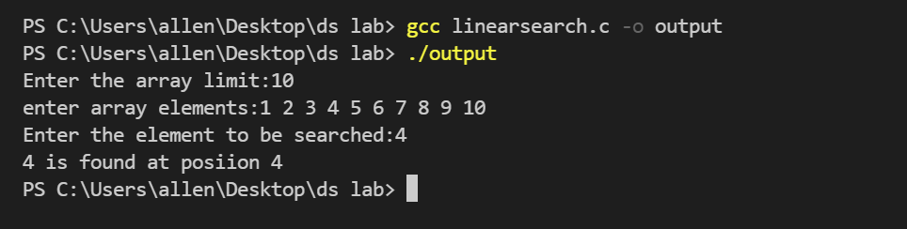

RESULT:

The program compiled and executed successfully

PROGRAM:

BINARY SEARCH

#include <stdio.h>
int main()
{
int arr[1000], i;
printf("Enter the number of the elements you want: ");
int n;
scanf("%d", &n);
printf("Enter the elements: ");
for (i = 0; i < n; i++)
{
scanf("%d", &arr[i]);
}
printf("Enter the element you want to find:");
int find = 0;
scanf("%d", &find); int flag = -1; int upbound = n; int lowbound = 0; int middle; while (flag == -1)
{
if (lowbound > upbound)
{
break;
}
middle = (upbound + lowbound) / 2;

if (arr[middle] < find) lowbound = middle + 1;
if (arr[middle] > find) upbound = middle - 1;
if (arr[middle] == find)
{
flag = middle; break;
} } if (flag == -1) printf("The element is not present in the array \n");
else printf("The element %d was found in the position %d \n", find, flag + 1);
}

OUTPUT:

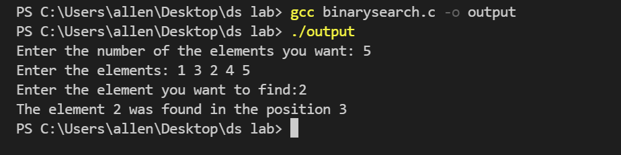

RESULT:

The program compiled and executed successfully

PROGRAM:

SPARSE REPRESENTATION

#include <stdio.h>
#define MAX_VAL 101
struct triple
{
int row; int col; int val;
} sparse[MAX_VAL];
void tripletrep(int arr[1000][1000], int n, int m);
void print(int k)
{
printf("The Triplet representation is\n");
int i, j;
for (i = 0; i < k; i++)
{
printf("%d %d %d \n", sparse[i].row, sparse[i].col, sparse[i].val);
}
}
int main()
{
int i, j;
printf("Enter the Order of the Sparse array: ");
int n, m;
scanf("%d %d", &n, &m);
int arr[1000][1000];
printf("Enter the elements: ");
for (i = 0; i < n; i++)
{
for (j = 0; j < m; j++)
scanf("%d", &arr[i][j]);
}
tripletrep(arr, n, m);
}
void tripletrep(int arr[1000][1000], int n, int m)
{
int i, j, k = 1;
for (i = 0; i < n; i++)
for (j = 0; j < m; j++)
{
if (arr[i][j] != 0)
{
sparse[k].row = i;
sparse[k].col = j;
sparse[k].val = arr[i][j];
k++;
}
}
sparse[0].row = i;
sparse[0].col = j;
sparse[0].val = k – 1;
print(k);
}

OUTPUT:

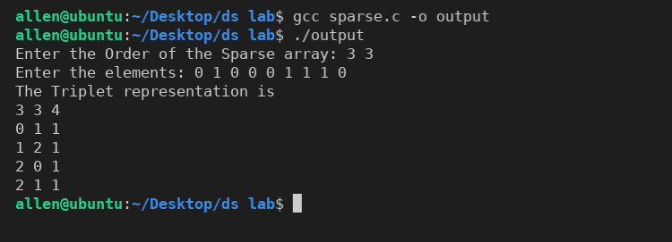

RESULT:

The program compiled and executed successfully

PROGRAM:

SUM OF SPARSE MATRIX

#include <stdio.h>
#define MAX_VAL 101
struct triple
{
int row; int col; int val;
} a[MAX_VAL], b[MAX_VAL], c[MAX_VAL];
void print(int n)
{
int i, j;
for (i = 0; i <= n; i++)
{
printf("%d %d %d \n", c[i].row, c[i].col, c[i].val); }
}
void add(int n, int m)
{
int i, j, k;
if (a[0].row == b[0].row && a[0].col == b[0].col)
{
c[0].row = a[0].row;
c[0].col = a[0].col;
i = j = k = 1;
while (i <= n && j <= m)
{
if (a[i].row == b[j].row && a[i].col == b[j].col)
{
c[k].row = a[i].row;
c[k].col = a[i].col;
c[k].val = a[i].val + b[j].val;
k++; i++; j++;
}
else if (a[i].row == b[j].row) {
if (a[i].col < b[j].col)
{
c[k].row = a[i].row;
c[k].col = a[i].col;
c[k].val = a[i].val;
k++; i++;
}
else
{
c[k].row = b[j].row;
c[k].col = b[j].col;
c[k].val = b[j].val;
k++; j++;
}
}
else if (a[i].row < b[i].row)
{
c[k].row = a[i].row;
c[k].col = a[i].col;
c[k].val = a[i].val;
k++; i++;
}
else
{ c[k].row = b[j].row;
c[k].col = b[j].col;
c[k].val = b[j].val;
k++; j++;
}
}
while (i <= n)
{
c[k].row = a[i].row;
c[k].col = a[i].col;
c[k].val = a[i].val;
k++; i++;
}
while (j <= m)
{
c[k].row = b[j].row;
c[k].col = b[j].col;
c[k].val = b[j].val;
k++; j++;
}
c[0].val = k - 1;
}
printf("The Sum triple sparse matrix is: \n");
print(k - 1);
}
int main()
{
printf("Enter the number of non negative terms in the sparse matrix1: ");
int n;
scanf("%d", &n);
printf("Enter the triple representaion of the sparse matrix1: ");
int i;
for (i = 0; i <= n; i++)
{
scanf("%d %d %d", &a[i].row, &a[i].col, &a[i].val);
}
printf("Enter the number of non negative terms in the sparse matrix2: ");
int m;
scanf("%d", &m);
printf("Enter the triple representaion of the sparse matrix2: ");
for (i = 0; i <= m; i++)
{
scanf("%d %d %d", &b[i].row, &b[i].col, &b[i].val);
}
add(n, m);
return 0;
}

OUTPUT:

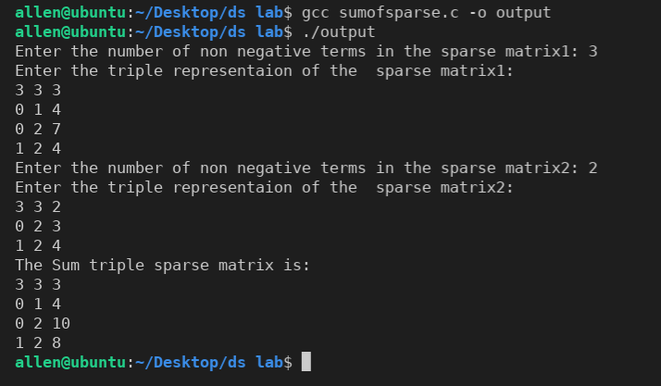

RESULT:

The program compiled and executed successfully

PROGRAM:
SPARSE TRANSPOSE:
#include <stdio.h>
#define MAX_VAL 101
struct triple
{
int row;
int col;
int val;
} sparse[MAX_VAL], sparsetrans[MAX_VAL];
void print(int n)
{
int i, j;
for (i = 0; i <= n; i++)
{
printf("%d %d %d \n", sparsetrans[i].row, sparsetrans[i].col, sparsetrans[i].val);
}
}
void trans(int n)
{
sparsetrans[0].row = sparse[0].col;
sparsetrans[0].col = sparse[0].row;
sparsetrans[0].val = sparse[0].val;
int q = 1;
int i = 0;
for (i = 0; i < sparse[0].col; i++)
{
int j;
for (j = 1; j <= n; j++)
{
if (sparse[j].col == i)
{
sparsetrans[q].row = sparse[j].col;
sparsetrans[q].col = sparse[j].row;
sparsetrans[q].val = sparse[j].val;
q++;
}
}
}
printf("\n The transpose sparse triplet representaion is: \n");
print(n);
}
int main()
{
printf("Enter the number of non negative terms in the sparse matrix: ");
int n;
scanf("%d", &n);
printf("Enter the triple representaion of the sparse matrix: ");
int i;
for (i = 0; i <= n; i++)
{
scanf("%d %d %d", &sparse[i].row, &sparse[i].col, &sparse[i].val);
}
trans(n);
return 0;
}

OUTPUT:

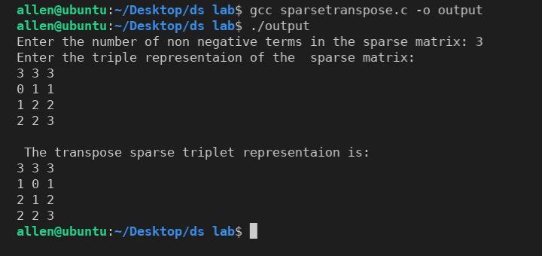

RESULT:

The program compiled and executed successfully

PROGRAM:

POLYNOMIAL ADDITION

#include <stdio.h>
typedef struct
{
int coeff;
int exp;
} poly;
void main()
{
poly p[10], q[10], r[20];
int i = 0, j = 0, k = 0, m, n;
printf("Enter number of term in poly A :");
scanf("%d", &n);
printf("Enter number of term in poly B :");
scanf("%d", &m);
printf("Enter the coeff and exp of poly A:\n");
for (i = 0; i < n; i++)
{
scanf("%d%d", &p[i].coeff, &p[i].exp);
}
printf("Enter the coeff and exp of poly B:\n");
for (i = 0; i < m; i++)
{
scanf("%d%d", &q[i].coeff, &q[i].exp);
}
i = 0;
while (i < n && j < m)
{
if (p[i].exp == q[j].exp)
{
r[k].coeff = p[i].coeff + q[j].coeff;
r[k].exp = p[i].exp;
i++, j++, k++;
}
else if (p[i].exp > q[j].exp)
{
r[k].coeff = p[i].coeff;
r[k].exp = p[i].exp;
i++, k++;
}
else
{
r[k].coeff = q[j].coeff;
r[k].exp = q[j].exp;
j++, k++;
}
}
while (i < n)
{
r[k].coeff = p[i].coeff;
r[k].exp = p[i].exp;
i++, k++;
}
while (j < m)
{
r[k].coeff = q[j].coeff;
r[k].exp = q[j].exp;
j++, k++;
}
printf("The Resultant polynomial is\n");
for (i = 0; i < k; i++)
{
printf("%dx^%d", r[i].coeff, r[i].exp);
if (i != (k – 1))
printf(" + ");
}
printf("\n");
}

OUTPUT:
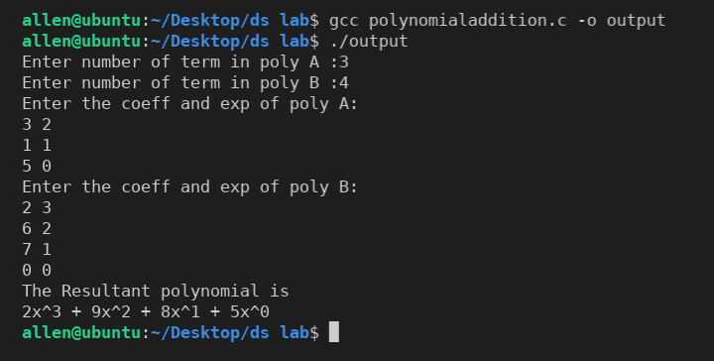

RESULT:

The program compiled and executed successfully

PROGRAM:
STACK
#include <stdio.h>
#define SIZE 2
int top = -1, stack[SIZE];
void push(int x)
{
if (top == SIZE – 1)
printf("Stack overflow\n");
else stack[++top] = x;
}
void pop()
{
if (top == -1) printf("Stack underflow\n");
else
{
printf("%d\n", stack[top]); top--;
}
}
void display()
{
int i;
printf("Content of the stack\n");
for (i = 0; i <= top; i++)
printf("%d\t", stack[i]);
printf("\n");
}
void main()
{
int x, option;
char c;
do
{
printf("Which operation is to be do\n1 : push\n2 : pop\n3 : Display elements\n");
scanf("%d", &option);
switch (option)
{
case 1:
{
printf("Enter element to push :");
scanf("%d", &x);
push(x);
break;
}
case 2:
{
pop();
break;
}
case 3:
{
display();
break;
}
default:
{
printf("Wrong Input\n");
}
}
getchar();
printf("Do you want to do it again(y/n) :");
scanf("%c", &c);
}
while (c == 'y' || c == 'Y');
printf("\n");
}

OUTPUT:

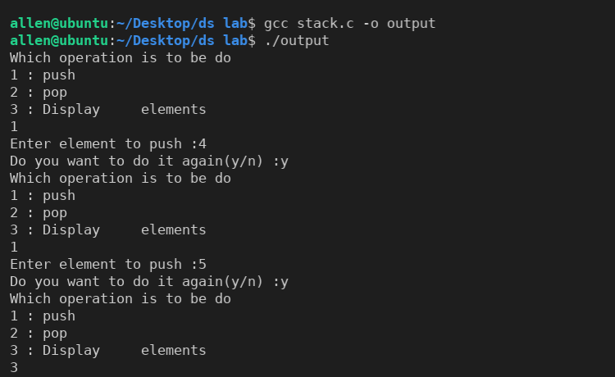

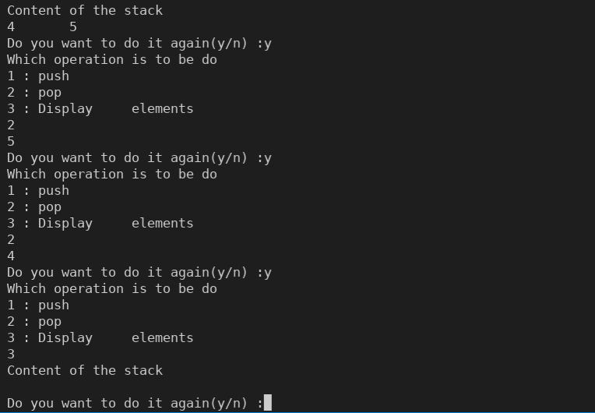

RESULT:

The program compiled and executed successfully

PROGRAM:
POSTFIX EVALUATION
#include <stdio.h>
#include <string.h> #define SIZE 100 int top = -1, stack[SIZE]; void push(double x)
{ if (top == SIZE - 1)
printf("Stack overflow\n");
else
stack[++top] = x;
}
double pop()
{ if (top == -1)
{
printf("Stack underflow\n"); return 0;
}
else
{ return stack[top--];
}
}
double operators(char c, double x, double y)
{
double result; switch (c)
{ case '+': result = x + y; break; case '*': result = x * y; break; case '/': result = x / y; break; case '-':
result = x - y; break; default:
printf("Wrong input");
} return result;
}
int check(char c)
{
switch (c)
{ case '+': return 0; break; case '*': return 0; break; case '/': return 0; break; case '-': return 0; break; default: return 1; } return -1;
} int main()
{
printf("Enter the postfix expression: ");
char postfix[100];
scanf("%s", postfix);
int n = strlen(postfix);
postfix[n] = '#';
int i = 0;
char item = postfix[0];
char op;
double result;
double x, y;
while (item != '#')
{
if (check(item))
{
push(item - '0');
}
else
{
op = item;
y = pop();
x = pop();
result = operators(op, x, y);
push(result);
}
item = postfix[++i];
}
double value = pop();
printf("The result of postfix expresionis: %f\n", value);
return 0;
}

OUTPUT:

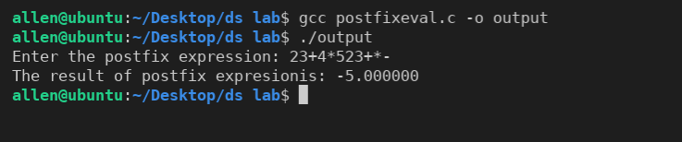

RESULT:

The program compiled and executed successfully

PROGRAM:

INFIX TO POSTFIX

#include <stdio.h>
#include <string.h>
#include <math.h>
#include <stdlib.h>
#define SIZE 100 int top = -1;
char stack[SIZE];
void push(char x)
{
if (top == SIZE - 1)
printf("Stack overflow");
else stack[++top] = x;
}
char pop()
{
if (top == -1)
{
printf("Stack underflow");
return '0';
}
else return
stack[top--];
}
int check(char c)
{
switch (c)
{
case '+':
case '*':
case '/':
case '-':
case '^':
case '(':
case ')':
return 0;
break;
default: return 1;
}
}
int isp(char x) {
switch (x)
{
case '+':
case '-':
return 2;
break;
case '/':
case '*':
return 4;
break;
case '^':
return 5;
break;
case '(':
return 0;
break;
default:
printf("invalid expression");
}
}
int icp(char x)
{
switch (x)
{
case '+':
case '-':
return 1;
break;
case '/':
case '*':
return 3;
break;
case '^':
return 6;
break;
case '(':
return 7;
break;
case ')':
return 0;
break;
default:
printf("invalid expression");
}
}
void infixtopostfix(char a[])
{
char item, x;
int i = 1;
push('(');
int n = strlen(a);
while (top > -1)
{
x = pop();
item = a[i];
if (check(item))
{
printf("%c", item);
push(x);
}
else if (item == ')')
{
while (x != '(')
{
printf("%c", x);
x = pop();
}
}
else if (isp(x) >= icp(item))
{
while (isp(x) >= icp(item))
{
printf("%c", x);
x = pop();
}
push(x);
push(item);
}
else if (isp(x) < icp(item))
{
push(x);
push(item);
}
i++;
}
}
int main()
{
printf("Enter the infix expression ");
char infix[100];
scanf("%s", infix);
infixtopostfix(infix);
printf("\n");
}

OUTPUT:

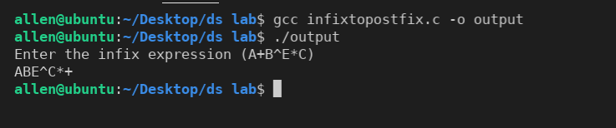

RESULT:

The program compiled and executed successfully

PROGRAM:
QUEUE
#include <stdio.h>
#define SIZE 3
int Q[SIZE], FRONT = -1, REAR = -1;
void enqueue()
{
int item;
if (REAR > SIZE - 1)
{
printf("Queue full!\n");
}
else
{
printf("Enter the element to be inserted : ");
scanf("%d", &item);
if (FRONT == -1 && REAR == -1)
{
FRONT = 0;
}
REAR++;
Q[REAR] = item;
}
}
void dequeue()
{
int item;
if (FRONT == -1)
{
printf("Queue empty!\n");
}
else
{
item = Q[FRONT];
if (FRONT == REAR)
{
FRONT = -1; REAR = -1;
}
else
{
FRONT++;
}
printf("The deleted element is : %d\n", item);
}
}
void Display()
{
int i;
if (FRONT == -1)
{
printf("Queue empty!\n");
}
else
{
printf("Elements are : ");
for (i = FRONT; i <= REAR; i++)
{
printf("%d\t", Q[i]);
}
printf("\n");
}
}
int main()
{
char ch;
do
{
printf("Press 'a' to perform enqueue.\n");
printf("Press 'b' to perform dequeue.\n");
printf("Press 'c' to display the queue elements.\n");
printf("Press 'd' to exit.\n");
printf("Enter an option (a/b/c/d) : ");
scanf("%c", &ch);
getchar();
switch (ch)
{
case 'a': enqueue(); break;
case 'b': dequeue(); break;
case 'c': Display(); break;
case 'd': break;
default: printf("Unknown option");
}
getchar();
}
while (ch != 'd');
return 0;
}

OUTPUT:

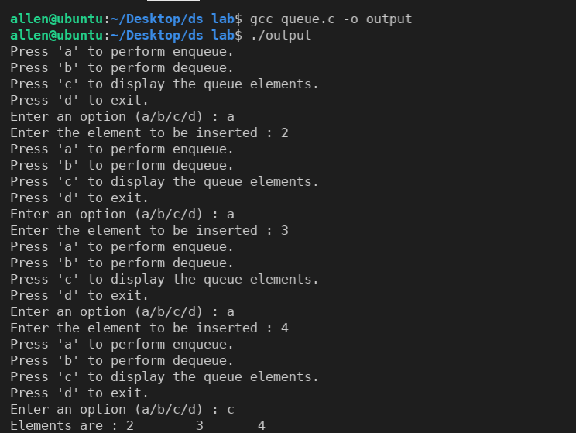

RESULT:

The program compiled and executed successfully

PROGRAM:

CIRCULAR QUEUE

#include <stdio.h>
#define SIZE 5
int CQ[SIZE], F = -1, R = -1;
void insertcq(int);
void deletecq(void);
void displaycq(void);
int main()
{
char ch; int n;
printf("Press 'a' to perform insert cqueue.\n");
printf("Press 'b' to perform delete cqueue.\n");
printf("Press 'c' to display cqueue.\n");
printf("Press 'd' to exit.\n");
printf("Enter an option (a/b/c/d) : ");
do
{
scanf("%c", &ch); switch (ch)
{
case 'a':
printf("Enter the no: to be inserted : ");
scanf("%d", &n);
insertcq(n);
break;
case 'b': deletecq(); break;
case 'c': displaycq(); break;
case 'd': break;
default: printf("Enter an option (a/b/c/d) : "); break;
}
} while (ch != 'd');
return 0;
}
void insertcq(int item)
{ int next; if (F == -1)
{
F = 0;
R = 0;
CQ[R] = item;
}
else
{
next = (R + 1) % SIZE;
if (next != F && next != SIZE)
{
R = next;
CQ[R] = item;
}
else
{
printf("Queue full\n");
}
}
}
void deletecq(void)
{
int item; if (F == -1)
{
printf("Queue empty\n");
}
else
{
item = CQ[F]; if (F == R)
{
F = -1;
R = -1;
}
else
{
F = (F + 1) % SIZE;
}
printf("The deleted item is : %d\n", item);
}
}
void displaycq(void)
{
int i;
if (F == -1)
{
printf("Queue empty!\n");
}
else
{
printf("FRONT : %d\n", F);
printf("REAR : %d\n", R);
printf("Elements are : ");
for (i = F; i != R; i = (i + 1) % SIZE)
{
printf("%d\t", CQ[i]);
}
printf("%d\n", CQ[R]);
}
}

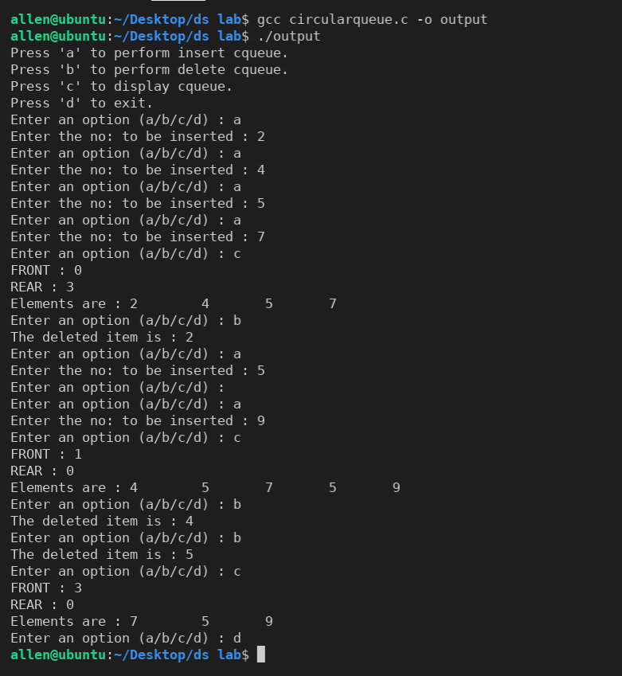
OUTPUT:

RESULT:

The program compiled and executed successfully

PROGRAM:

DEQUEUE
#define SIZE 5
#include <stdio.h>
int dq[SIZE], F = -1, R = -1;
void insert_frontdq(int);
void delete_reardq(void);
void displaydq(void);
int main()
{
char ch;
int n;
printf("Press 'a' to perform insert dqueue at front.\n");
printf("Press 'b' to perform delete dqueue at rear.\n");
printf("Press 'c' to display dqueue.\n");
printf("Press 'd' to exit.\n");
printf("Enter an option (a/b/c/d) : ");
do
{
scanf("%c", &ch);
switch (ch)
{
case 'a':
printf("Enter the no: to be inserted : ");
scanf("%d", &n);
insert_frontdq(n);
break;
case 'b': delete_reardq(); break;
case 'c': displaydq(); break;
case 'd': break;
default: printf("Enter an option (a/b/c/d) : ");
break;
}
} while (ch != 'd');
return 0;
}
void insert_frontdq(int item)
{
int ahead;
if (F == -1)
{
F = 0; R = 0; dq[F] = item;
}
else
{
if (F == 0)
{
ahead = SIZE - 1;
}
else
{
ahead = F - 1;
}
if (ahead == R)
{ printf("Queue full\n");
}
else
{
F = ahead; dq[F] = item;
}
}
}
void delete_reardq(void)
{
int item; if (F == -1)
{
printf("Queue empty\n");
}
else
{
if (F == R)
{
item = dq[R];
F = -1;
R = -1;
}
else if (R == 0)
{
item = dq[R];
R = SIZE - 1;
}
else
{
item = dq[R];
R--;
}
printf("The deleted element is : %d\n", item);
}
}
void displaydq(void)
{
int i;
if (F == -1)
{
printf("Queue empty!\n");
}
else
{
printf("FRONT : %d\n", F);
printf("REAR : %d\n", R);
printf("Elements are : ");
for (i = F; i != R; i = (i + 1) % SIZE)
{
printf("%d\t", dq[i]);
}
printf("%d\n", dq[R]);
}
}

OUTPUT:
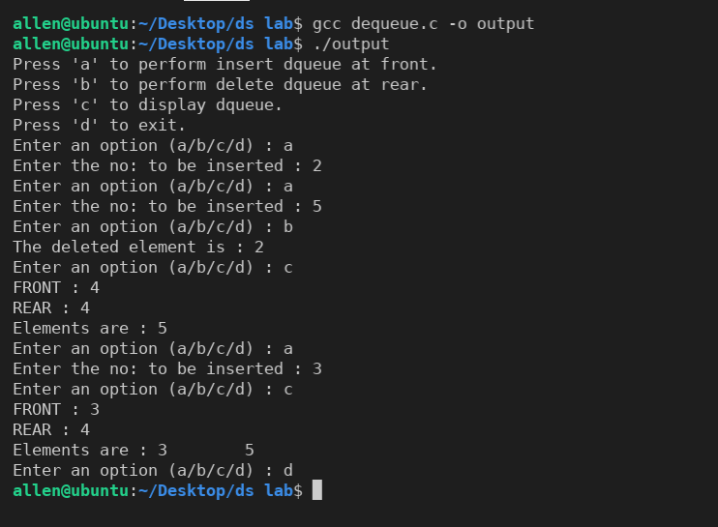

RESULT:

The program compiled and executed successfully

PROGRAM:
PRIORITY QUEUE
#include <stdio.h>
#define SIZE 5
typedef struct
{
int element; int priority;
} priorq;
priorq pq[SIZE];
int F = -1, R = -1;
void insertpq(int, int);
void display(void);
int get_highest_priority(void);
void delete_highest_priority(void);
int main()
{
char ch;
int item, prior, max;
printf("Press 'a' to insert an element.\n");
printf("Press 'b' to get highest priority element\n");
printf("Press 'c' to delete highest priority element.\n");
printf("Press 'd' to display elements.\n");
printf("Press 'e' to exit.\n");
printf("Enter the choice (a/b/c/d/e) : ");
do
{
scanf("%c", &ch);
switch (ch)
{
case 'a':
printf("Enter the element to be inserted : ");
scanf("%d", &item);
printf("Enter its priority : ");
scanf("%d", &prior);
insertpq(item, prior);
break;
case 'b':
max = get_highest_priority();
printf("The highest priority item is : %d\n", max);
break;
case 'c':
delete_highest_priority(); break;
case 'd': display(); break;
case 'e': break;
default: printf("Enter your choice (a/b/c/d/e) :"); break;
}
} while (ch != 'e');
return 0;
}
void insertpq(int item, int prior)
{ if (R >= SIZE - 1)
{
printf("Queue full!\n");
}
else
{
if (F == -1 && R == -1)
{
F = 0;
}
R++;
pq[R].element = item;
pq[R].priority = prior;
}
}
int get_highest_priority(void)
{
int maxp = 0, maxi, i;
for (i = F; i <= R; i++)
{
if (pq[i].priority > maxp)
{
maxp = pq[i].priority;
maxi = pq[i].element;
}
}
return maxi;
}
void delete_highest_priority(void)
{
int m, i, j;
m = get_highest_priority();
if (R == -1)
{
printf("Queue empty\n");
}
else
{
for (i = F; pq[i].element != m; i++);
for (j = i; j < R; j++)
{
pq[j].element = pq[j + 1].element;
pq[j].priority = pq[j + 1].priority;
}
R--;
}
}
void display(void)
{
int i;
if (R == -1)
{
printf("Queue empty\n");
}
else
{ for (i = F; i <= R; i++)
{
printf("Element : %d\tPriority :%d\n", pq[i].element, pq[i].priority);
}
}
}

OUTPUT:

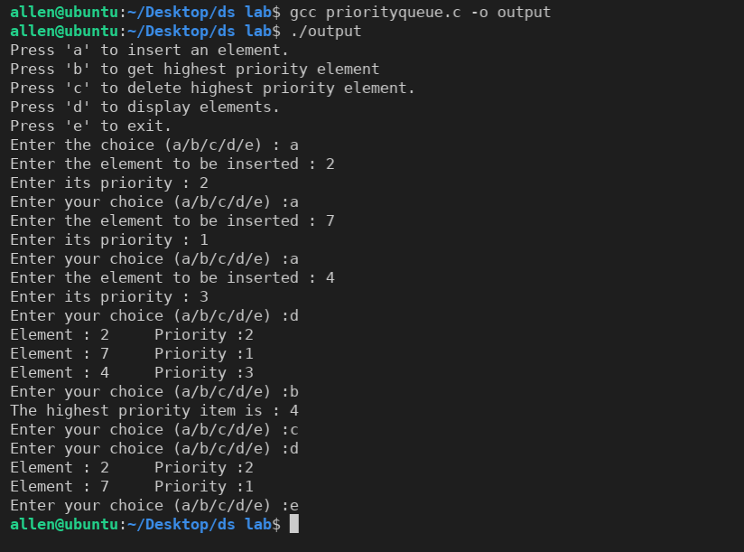

RESULT:

The program compiled and executed successfully

PROGRAM:
LINKED LIST
#include <stdio.h>
#include <stdlib.h>
typedef struct node1
{
int data;
struct node1 *link;
} node;
node *CreateNode(int n)
{
node *header = (node *)malloc(sizeof(node));
node *ptr1;
ptr1 = header;
header->data = 0;
header->link = NULL;
for (int i = 0; i < n; i++)
{
node *ptr2 = (node *)malloc(sizeof(node));
printf("Enter the element: ");
scanf("%d", &ptr2->data);
ptr2->link = NULL;
ptr1->link = ptr2;
ptr1 = ptr1->link;
}
return header;
}
void TraverseNode(node *header)
{
if (header->link == NULL)
{
printf("Empty set");
}
else
{
node *ptr = header->link;
printf("The element are: \n");
while (ptr != NULL)
{
printf("%d\t", ptr->data);
ptr = ptr->link;
}
}
printf("\n");
}
void DeleteNodeFirst(node *header)
{
node *ptr1 = header->link;
header->link = ptr1->link;
free(ptr1);
}
void InsertNodeFirst(node *header, int data)
{
node *ptr1 = header->link;
node *ptr2 = (node *)malloc(sizeof(node));
ptr2->data = data;
header->link = ptr2;
ptr2->link = ptr1;
}
void DeleteNodeEnd(node *header)
{
node *ptr1 = header;
while (ptr1->link->link != NULL)
ptr1 = ptr1->link;
node *ptr2 = ptr1->link;
ptr1->link = NULL;
free(ptr2);
}
void InsertNodeEnd(node *header, int data)
{
node *ptr1 = header;
while (ptr1->link != NULL)
ptr1 = ptr1->link;
node *ptr2 = (node *)malloc(sizeof(node));
ptr2->link = NULL;
ptr2->data = data;
ptr1->link = ptr2;
}
void DeleteNode(node *header, int key)
{
node *ptr1 = header;
node *ptr2;
int postion = 0;
while (ptr1->link->data != key && ptr1->link != NULL)
{
ptr1 = ptr1->link;
postion++;
}
if (ptr1->link->data == key)
{
if (ptr1->link->link == NULL)
{
DeleteNodeEnd(header);
}
else if (postion == 0)
{
DeleteNodeFirst(header);
}
else
{
ptr2 = ptr1->link;
ptr1->link = ptr1->link->link;
free(ptr2);
}
}
else
{
printf("Element not present in the list\n");
}
}
void InsertNode(node *header, int pos, int data)
{
node *ptr1 = header;
node *ptr2 = (node *)malloc(sizeof(node));
int postion = 0;
while (postion != (pos - 1) && ptr1->link != NULL)
{
ptr1 = ptr1->link;
postion++;
}
if (postion == pos - 1)
{
if (postion == 1)
{
InsertNodeFirst(header, data);
}
else
{
ptr2->data = data;
ptr2->link = ptr1->link;
ptr1->link = ptr2;
}
}
else
{
printf("Invalid postion\n");
}
}
int main()
{
printf("Enter the number of nodes you want in the linked list: ");
int x;
scanf("%d", &x);
node *header = CreateNode(x); TraverseNode(header);
int y; char c; int option;
printf("Operations\n1 - Deletion from the front\n2 - Deletion from the end\n3 - Deletion from
any position\n4 - Insertion from the front\n5 - Insetion from the end\n6 - Insertion from any position\n7 – Display\n");
do
{
printf("Enter(1 2 3 4 5 6 7) :");
scanf("%d", &option);
switch (option)
{
case 1:
DeleteNodeFirst(header); break;
case 2:
DeleteNodeEnd(header); break;
case 3:
printf("Enter key :");
scanf("%d", &y);
DeleteNode(header, y);
break;
case 4:
printf("Enter data :");
scanf("%d", &y);
InsertNodeFirst(header, y);
break;
case 5:
printf("Enter data :");
scanf("%d", &y);
InsertNodeEnd(header, y);
break;
case 6:
printf("Enter the position and data :");
int pos;
scanf("%d %d", &pos, &y);
InsertNode(header, pos, y);
break;
case 7:
TraverseNode(header);
break;
default:
printf("Wrong option"); break;
}
printf("Do want to perform more operations ?(y/n) :");
scanf(" %c", &c);
}
while (c == 'y' || c == 'Y');
return 0;
}

OUTPUT:

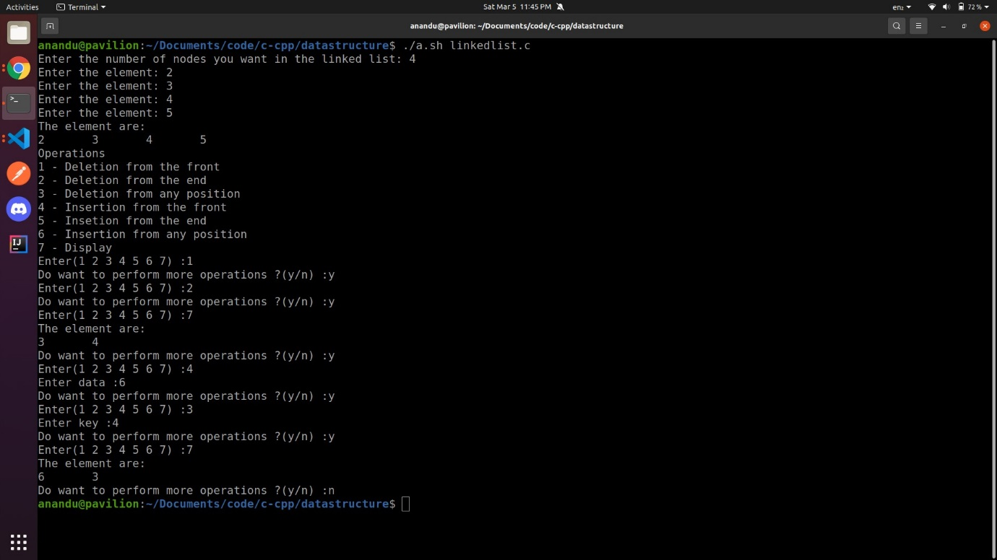

RESULT:

The program compiled and executed successfully
PROGRAM:

STACK AS A LINKED LIST

#include <stdio.h>
#include <stdlib.h>
typedef struct node1
{
int data;
struct node1 *link;
} node;
node *TOP = NULL, *header;
void CreateNode()
{
header = (node *)malloc(sizeof(node)); header->link = NULL;
}
void TraverseNode()
{
if (TOP == NULL)
{
printf("Empty set");
}
else
{
node *ptr = TOP;
printf("The element are: \n");
while (ptr != NULL)
{
printf("%d\t", ptr->data);
ptr = ptr->link;
}
}
printf("\n");
}
void POP()
{
if (TOP == NULL)
{
printf("The stack is empty!\n");
}
else
{
node *ptr = TOP->link;
printf("%d\n", TOP->data);
header->link = ptr;
free(TOP);
TOP = ptr;
}
}
void PUSH(int data)
{
node *ptr = (node *)malloc(sizeof(node));
ptr->data = data;
ptr->link = TOP;
TOP = ptr;
header->link = TOP;
}
int main()
{
CreateNode();
int y; char c;
int option;
printf("Operations\n1 - POP\n2 - PUSH\n3 – Display\n");
do
{
printf("Enter(1 2 3) :");
scanf("%d", &option);
switch (option)
{
case 1:
POP(); break;
case 2:
printf("Enter data :");
scanf("%d", &y);
PUSH(y); break;
case 3: TraverseNode(); break;
default: printf("Wrong option\n"); break;
}
printf("Do want to perform more operations ?(y/n) :");
scanf(" %c", &c);
} while (c == 'y' || c == 'Y');
return 0;
}

OUTPUT:
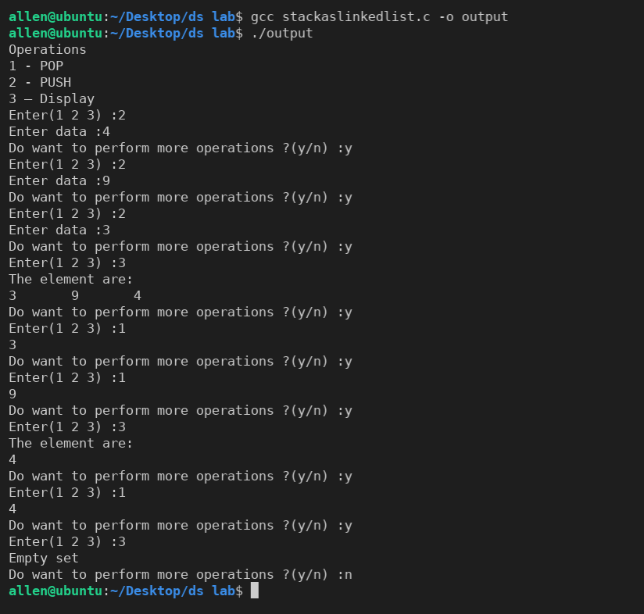

RESULT:

The program compiled and executed successfully

PROGRAM:

DOUBLY LINKED LIST

#include <stdio.h>
#include <stdlib.h>
typedef struct node1
{
int data;
struct node1 *Llink;
struct node1 *Rlink;
} node;
node *CreateNode(int n)
{
node *header = (node *)malloc(sizeof(node));
node *ptr1; ptr1 = header;
header->data = 0;
header->Llink = NULL;
header->Rlink = NULL;
for (int i = 0; i < n; i++)
{
node *ptr2 = (node *)malloc(sizeof(node));
printf("Enter the element: ");
scanf("%d", &ptr2->data);
ptr2->Rlink = NULL;
ptr2->Llink = ptr1;
ptr1->Rlink = ptr2;
ptr1 = ptr1->Rlink;
}
return header;
}
void TraverseNode(node *header)
{
if (header->Rlink == NULL)
{
printf("Empty set");
}
else
{
node *ptr = header->Rlink;
printf("The element are: \n");
while (ptr != NULL)
{
printf("%d\t", ptr->data);
ptr = ptr->Rlink;
}
}
printf("\n");
}
void DeleteNodeFirst(node *header)
{
node *ptr1 = header->Rlink;
node *ptr2; ptr2 = ptr1->Rlink;
if (ptr2 != NULL)
ptr2->Llink = header;
header->Rlink = ptr2;
free(ptr1);
}
void InsertNodeFirst(node *header, int data)
{
node *ptr1 = header->Rlink;
node *ptr2 = (node *)malloc(sizeof(node));
ptr2->data = data;
ptr2->Llink = header;
header->Rlink = ptr2;
ptr2->Rlink = ptr1;
}
void DeleteNodeEnd(node *header)
{
node *ptr1 = header;
while (ptr1->Rlink != NULL)
ptr1 = ptr1->Rlink;
node *ptr2 = ptr1->Llink;
ptr2->Rlink = NULL; free(ptr1);
}
void InsertNodeEnd(node *header, int data)
{
node *ptr1 = header;
while (ptr1->Rlink != NULL)
ptr1 = ptr1->Rlink;
node *ptr2 = (node *)malloc(sizeof(node));
ptr2->Rlink = NULL;
ptr2->data = data;
ptr2->Llink = ptr1;
ptr1->Rlink = ptr2;
}
void DeleteNode(node *header, int key)
{
node *ptr1 = header;
node *ptr2;
int postion = 0;
while (ptr1->data != key && ptr1->Rlink != NULL)
{
ptr1 = ptr1->Rlink; postion++;
}
if (ptr1->data == key)
{
if (ptr1->Rlink == NULL)
{
DeleteNodeEnd(header);
}
else if (postion == 1)
{
DeleteNodeFirst(header);
}
else
{
ptr2 = ptr1->Llink;
ptr2->Rlink = ptr1->Rlink;
ptr1->Rlink->Llink = ptr2;
free(ptr1);
}
}
else
{
printf("Element not present in the list");
}
}
void InsertNode(node *header, int pos, int data)
{
node *ptr1 = header;
node *ptr2 = (node *)malloc(sizeof(node));
int postion = 0;
while (postion != pos && ptr1->Rlink != NULL)
{
ptr1 = ptr1->Rlink; postion++;
}
if (postion == pos)
{
if (postion == 1)
{
InsertNodeFirst(header, data);
}
else
{
ptr2->data = data;
ptr1->Llink->Rlink = ptr2;
ptr2->Llink = ptr1->Llink;
ptr1->Llink = ptr2;
ptr2->Rlink = ptr1;
}
}
else
{
printf("Invalid postion\n");
}
}
int main()
{
printf("Enter the number of nodes you want in the linked list: ");
int x;
scanf("%d", &x);
node *header = CreateNode(x);
TraverseNode(header);
int y; char c; int option;
printf("Operations\n1 - Deletion from the front\n2 - Deletion from the end\n3 - Deletion from
any position\n4 - Insertion from the front\n5 - Insetion from the end\n6 - Insertion from any position\n7 - Display\n");
do
{
printf("Enter(1 2 3 4) :");
scanf("%d", &option);
switch (option)
{
case 1:
DeleteNodeFirst(header); break;
case 2:
DeleteNodeEnd(header); break;
case 3:
printf("Enter key :");
scanf("%d", &y); DeleteNode(header, y); break;
case 4:
printf("Enter data :"); scanf("%d", &y); InsertNodeFirst(header, y); break;
case 5:
printf("Enter data :"); scanf("%d", &y); InsertNodeEnd(header, y); break;
case 6:
printf("Enter the position and data :");
int pos;
scanf("%d %d", &pos, &y);
InsertNode(header, pos, y); break;
case 7:
TraverseNode(header); break;
default:
printf("Wrong option"); break;
}
printf("Do want to perform more operations ?(y/n) :");
scanf(" %c", &c);
} while (c == 'y' || c == 'Y');
return 0;
}

OUTPUT:

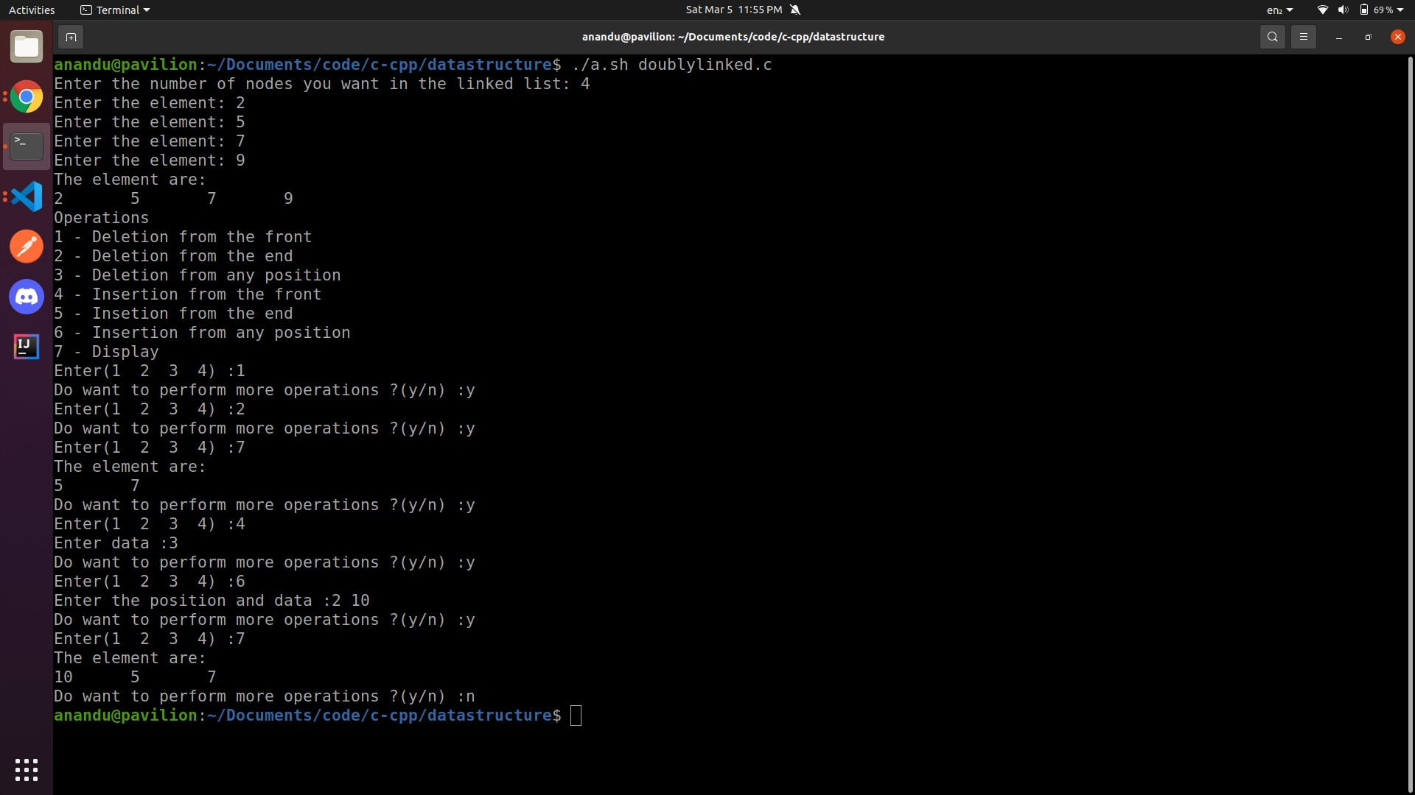

RESULT:

The program compiled and executed successfully

PROGRAM:
QUEUE AS A LINKED LIST
#include <stdio.h>
#include <stdlib.h>
typedef struct node1
{
int data;
struct node1 *link;
} node;
node *FRONT, *REAR, *header;
void CreateNode()
{
header = (node *)malloc(sizeof(node));
header->link = NULL;
}
void TraverseNode()
{
if (FRONT == NULL)
{
printf("Empty set");
}
else
{
node *ptr = FRONT;
printf("The element are: \n");
while (ptr != NULL)
{
printf("%d\t", ptr->data);
ptr = ptr->link;
}
}
printf("\n");
}
void DeleteQ()
{
if (FRONT == NULL)
{
printf("The Queue is empty!\n");
}
else
{
printf("%d\n", FRONT->data);
header->link = FRONT->link;
free(FRONT);
FRONT = header->link;
}
}
void InsertQ(int data)
{
node *temp= (node *)malloc(sizeof(node));
temp->data = data;
temp->link = NULL;
if (header->link == NULL)
{
header->link = temp;
FRONT = temp;
REAR = temp;
}
else
{
REAR->link = temp;
REAR = temp;
}
}
int main()
{
CreateNode();
int y; char c; int option;
printf("Operations\n1 - DeleteQ\n2 - InsertQ\n3 - Display\n");
do
{
printf("Enter(1 2 3) :");
scanf("%d", &option);
switch (option)
{
case 1: DeleteQ(); break;
case 2:
printf("Enter data :");
scanf("%d", &y);
InsertQ(y);
break;
case 3: TraverseNode(); break;
default: printf("Wrong option"); break;
}
printf("Do want to perform more operations ?(y/n) :");
scanf(" %c", &c);
} while (c == 'y' || c == 'Y');
return 0;
}

OUTPUT:

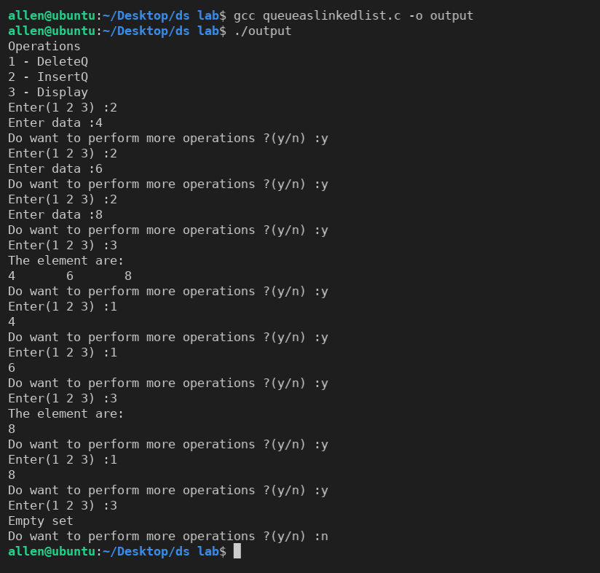

RESULT:

The program compiled and executed successfully

PROGRAM:
POLYNOMIAL ADDITION USING LINKED LIST

#include <stdio.h>
#include <stdlib.h>
typedef struct poly1
{
int coeff; int exp;
struct poly1 *next;
} poly;
void display(poly *header);
poly *Qheader, *Pheader, *Rheader;
poly *getnode()
{
poly *temp = (poly *)malloc(sizeof(poly));
temp->coeff = 0; temp->exp = 0;
temp->next = NULL;
return temp;
}
poly *Createpolynomial()
{
printf("Enter the degree of the poynomial: ");
int n; scanf("%d", &n);
poly *header = getnode();
poly *ptr1 = header;
for (int i = n; i >= 0; i--)
{
printf("Enter the value: ");
int x;
scanf("%d", &x);
if (x == 0)
continue;
poly *temp = getnode();
temp->coeff = x; temp->exp = i;
ptr1->next = temp;
ptr1 = ptr1->next;
}
return header;
}
void polyadd()
{
Rheader = getnode(); poly *Rptr = Rheader;
poly *Pptr = Pheader->next;
poly *Qptr = Qheader->next;
while (Pptr != NULL && Qptr != NULL)
{
if (Pptr->exp == Qptr->exp)
{
poly *temp = getnode();
temp->exp = Pptr->exp;
temp->coeff = Pptr->coeff + Qptr->coeff;
Pptr = Pptr->next;
Qptr = Qptr->next;
Rptr->next = temp;
Rptr = Rptr->next;
}
else if (Pptr->exp > Qptr->exp)
{
poly *temp = getnode();
temp->exp = Pptr->exp;
temp->coeff = Pptr->coeff;
Pptr = Pptr->next;
Rptr->next = temp;
Rptr = Rptr->next;
}
else if (Pptr->exp < Qptr->exp)
{
poly *temp = getnode();
temp->exp = Qptr->exp;
temp->coeff = Qptr->coeff;
Qptr = Qptr->next;
Rptr->next = temp;
Rptr = Rptr->next;
}
}
while (Pptr != NULL)
{
poly *temp = getnode();
temp->exp = Pptr->exp;
temp->coeff = Pptr->coeff;
Pptr = Pptr->next;
Rptr->next = temp;
Rptr = Rptr->next;
}
while (Qptr != NULL)
{
poly *temp = getnode();
temp->exp = Qptr->exp;
temp->coeff = Qptr->coeff;
Qptr = Qptr->next;
Rptr->next = temp;
Rptr = Rptr->next;
}
}
void display(poly *header)
{
printf("\n");
poly *ptr = header->next;
while (ptr != NULL)
{
if (ptr->next != NULL)
{
printf("%dX^%d + ", ptr->coeff, ptr->exp);
}
else
{
printf("%dX^%d ", ptr->coeff, ptr->exp);
}
ptr = ptr->next;
}
}
int main()
{
printf("First polynomial!\n");
Pheader = Createpolynomial();
display(Pheader);
printf("\n");
printf("Second polynomial!\n");
Qheader = Createpolynomial();
printf("\n");
display(Qheader);
printf("\n"); polyadd(); display(Rheader);
}

OUTPUT:

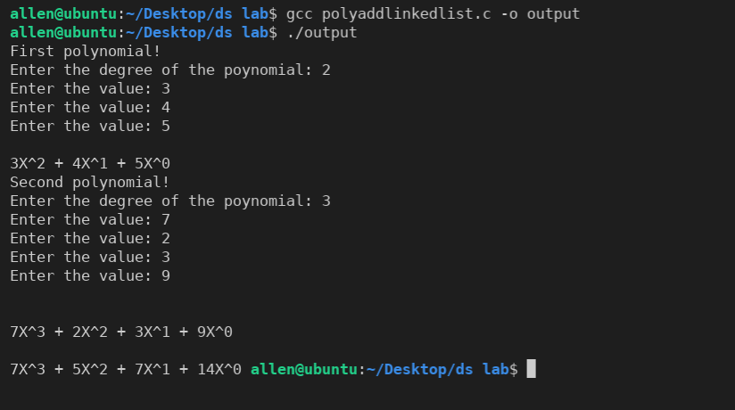

RESULT:

The program compiled and executed successfully

PROGRAM:
BINARY TREE
#include <stdio.h>
#include <stdlib.h>
#define SIZE 1000
typedef struct bin
{
struct bin *Lchild;
char data;
struct bin *Rchild;
} BT;
BT *ROOT;
BT *GetNode()
{
BT *temp = (BT *)malloc(sizeof(BT));
temp->data = '\0'; temp->Lchild = NULL;
temp->Rchild = NULL;
return temp;
}
void binarytree_creation(BT *bt, char data)
{
if (bt != NULL)
{
bt->data = data;
A:
printf("Do you want a Left child for %c (Y/N): ", bt->data);
char option; getchar();
scanf("%c", &option);
if (option == 'Y' || option == 'y')
{
bt->Lchild = GetNode();
printf("Enter the value for the left child of %c : ", bt->data);
char value; getchar(); scanf("%c", &value);
binarytree_creation(bt->Lchild, value);
}
else if (option == 'N' || option == 'n')
{
bt->Lchild = NULL;
binarytree_creation(NULL, '\0');
}
else
{
printf("Invalid option\n"); goto A;
}
B:
printf("Do you want a Rigth child for %c (Y/N): ", bt->data);
getchar();
scanf("%c", &option);
if (option == 'Y' || option == 'y')
{
bt->Rchild = GetNode();
printf("Enter the value for the Rigth child of %c: ", bt->data);
char value; getchar();
scanf("%c", &value);
binarytree_creation(bt->Rchild, value);
}
else if (option == 'N' || option == 'n')
{
bt->Rchild = NULL;
binarytree_creation(NULL, '\0');
}
else
{
printf("Invalid option\n"); goto B;
}
} return;
}
void Preorder_rec(BT *ptr)
{
if (ptr != NULL)
{
printf("%c\t", ptr->data);
Preorder_rec(ptr->Lchild);
Preorder_rec(ptr->Rchild);
}
}
void Postorder_rec(BT *ptr)
{
if (ptr != NULL)
{
Postorder_rec(ptr->Lchild);
Postorder_rec(ptr->Rchild);
printf("%c\t", ptr->data);
}
}
void Inorder_rec(BT *ptr)
{
if (ptr != NULL)
{
Inorder_rec(ptr->Lchild);
printf("%c\t", ptr->data);
Inorder_rec(ptr->Rchild);
}
}
int main()
{
printf("Creating Binary tree-------\n");
printf("Creating root node\n");
printf("Enter the value in Root node: ");
ROOT = GetNode();
char data; scanf("%c", &data);
printf("Creating Subtrees\n: "); binarytree_creation(ROOT, data); printf("\nPreorder Traversal: "); Preorder_rec(ROOT);
printf("\n"); // Preorder(); printf("\n");
printf("\nPostorder Traversal: ");
Postorder_rec(ROOT);
printf("\n"); // Postorder(); printf("\n");
printf("\nInorder Traversal: ");
Inorder_rec(ROOT);
printf("\n"); // Inorder(); printf("\n");
}

OUTPUT:

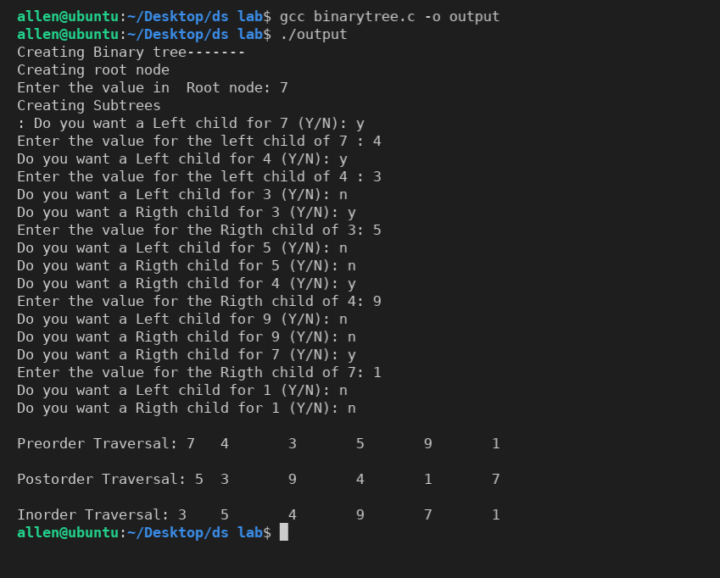

RESULT:

The program compiled and executed successfully

